TASK :

Implementing a Multi-threaded Application to Fetch Data from a Database​

​

**Statement:** Implement a Java application that creates multiple threads, with each thread responsible for fetching data from a different table in a PostgreSQL database using JDBC. The application should concurrently retrieve and print the data from the tables.​

**Requirements:**​

* Create a PostgreSQL database with multiple tables (e.g., employees, departments, projects).​
* Implement a thread class that connects to the database and fetches data from a specified table.​
* Start multiple threads, each fetching data from a different table.​
* Use JDBC to connect to the PostgreSQL database and retrieve the data.​

package com.company;  
import javax.xml.crypto.Data;  
import java.sql.Connection;  
import java.sql.DriverManager;  
import java.sql.ResultSet;  
import java.sql.Statement;  
import java.sql.SQLException;  
  
import java.sql.Connection;  
  
public class Main {  
  
 public static void main(String[] args) {  
  
 String dbUrl = "jdbc:postgresql://localhost:5432/mydatabase";  
 String user = "postgres";  
 String password = "root";  
  
 Thread empt1 = new DataFetcherThread("employees",dbUrl,user,password);  
 Thread dept2 = new DataFetcherThread("departments",dbUrl,user,password);  
 Thread prot3 = new DataFetcherThread("projects",dbUrl,user,password);  
  
 empt1.start();  
 dept2.start();  
 prot3.start();  
  
 try{  
  
 empt1.join();  
 dept2.join();  
 prot3.join();  
 }  
 catch(InterruptedException e){  
 e.printStackTrace();  
 }  
  
 System.*out*.println("Data fetching completed");  
 }  
}

public class DataFetcherThread extends Thread {  
  
 private String tableName;  
 private String dbUrl;  
 private String user;  
 private String password;  
  
 private static final Object *syncObject* = new Object();  
  
 public DataFetcherThread(String tableName, String dbUrl, String user, String password) {  
  
 this.tableName=tableName;  
 this.dbUrl=dbUrl;  
 this.user=user;  
 this.password=password;  
 }  
  
 public void run() {  
  
 Connection conn = null;  
 Statement stmt = null;  
  
 try{  
  
 conn = DriverManager.*getConnection*(dbUrl,user,password);  
 stmt=conn.createStatement();  
 String sql = "select * from "+tableName;  
 ResultSet rs = stmt.executeQuery(sql);  
  
 synchronized (*syncObject*){  
  
 System.*out*.println("Table : " + tableName + " | ");  
 System.*out*.println();  
 int colcount = rs.getMetaData().getColumnCount();  
  
 while(rs.next()) {  
  
 for(int i=1;i<=colcount;i++) {  
 String colName = rs.getMetaData().getColumnName(i);  
 String colValue = rs.getString(i);  
 System.*out*.println(colName + " : " + colValue + " | ");  
 }  
 System.*out*.println();  
 }  
 System.*out*.println("End of data from table : " + tableName);  
 System.*out*.println();  
 }  
  
  
 rs.close();  
 stmt.close();  
 conn.close();  
 }  
 catch(Exception e){  
 e.printStackTrace();  
 }  
 finally {  
 try{  
 if(stmt!=null){  
 stmt.close();  
 }  
 if(conn!=null){  
 conn.close();  
 }  
 }  
 catch(Exception e){  
 e.printStackTrace();  
 }  
 }  
 }  
}

Data entered into PostgreSQL :

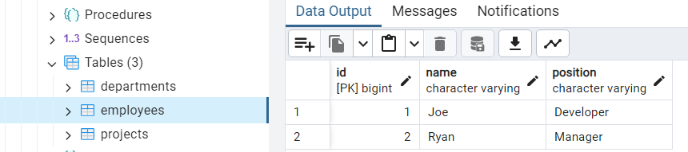

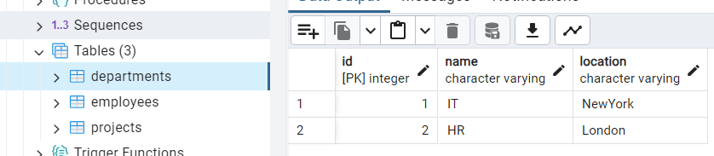

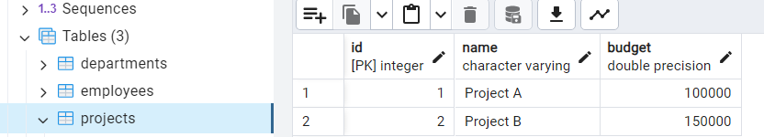

OUTPUT :

